Page 6 of Chapter1 Part 1

One important point here one should pay attention is that the “Sample Space” depends on not only how the experiment is carried out, but also the “problem of interest”. Also refer to page 7 for an example.

Page 8 of Chapter1 Part 1
If the dice are labelled, i.e., whether the first die shows 1 or the second shows 1 matters, the sample space is the one given in the slides; each observation in this sample space is equally likely to appear. If the two dice are not labelled, the sample space is

$$S=\{\{1,1\}, \{1,2\}, \{1,3\}, \{1,4\}, \{1,5\}$$
$\left\{2,2\right\}, \left\{2,3\right\}, \left\{2,4\right\}, \left\{2,5\right\}, \{2,6\}$

$\left\{3,3\right\}, \left\{3,4\right\}, \left\{3,5\right\}, \{3,6\}$
$$\left\{4,4\right\}, \left\{4,5\right\},\{4,6\}$$
$$\left\{5,5\right\}, \{5,6\}$$
$$\{6,6\}\}$$
But now, take note that the each observation in the sample space is not equally likely; in other words, their chance of appearance are not the same. In particular, “{1,1}“ is less likely to appear than “{1,2}”.

Page 15 of Chapter1 Part 1
In principle, any arbitrary subset of the sample space can be an event. So, for a sample space with n number of possible sample points, there are $2^{n}$ number of possible events (we shall be able to verify this rigorously after we have learned “combinations”), including the empty event (null event), denoted by $∅$ by convention. Here empty event is the event which contains no sample point. So, if S={1,2,3,4,5,6}, the number of possible event is $2^{6}=64$, which is quite a big number, and it is not feasible for us to list them all. In this slide, it gives some frequently used events in practice.
Here is one take home question to practice: if S = {1,2,3} so that we have 8 possible events, please try to write down all the possible events relating to this sample space.

Page 29 of Chapter1 Part 1
($A∪B)'=A'∩B'$ is in fact the special case of the De Morgan’s Law. So you may read this caculation jointly with page 36:

Also, you can refer to page 34 and 35, points 5 and 6.

Page 34&35 of Chapter1 Part 1
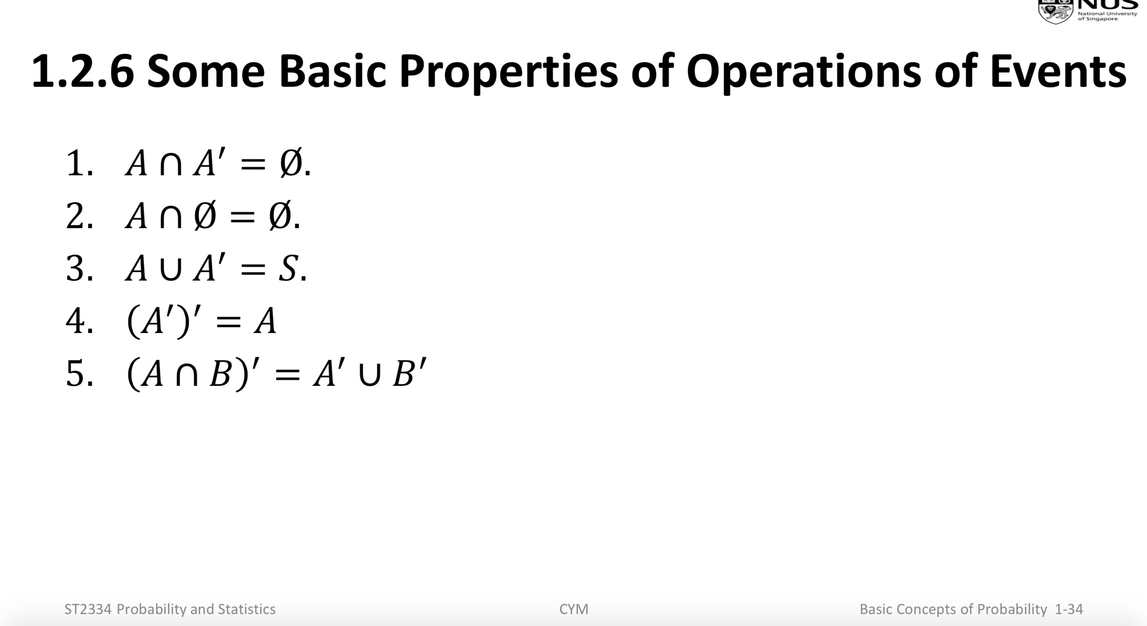
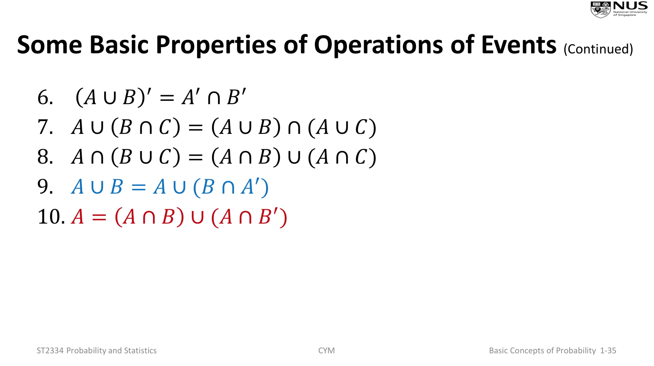
- These are very useful formulae.
- Besides, you may also add the formulae discussed in pages 27 and 28:
$$A∩B∩C=\left(A∩B\right)∩C=A∩(B∩C)$$
$$A∪B∪C=\left(A∪B\right)∪C=A∪(B∪C)$$
- Also take note that $A∩\left(B∪C\right)≠\left(A∩B\right)∪C$; in other words, when the operations are not of the same type, which operation being done first matters.
- Property 9 in the above slides essentially gives one mutually exclusive partition for $A∪B$, in other words, besides $A∪B=A∪(B∩A)'$, we should also observe $A∩{\left(B∩A\right)}^{'}= ∅$. So, is there any other mutually exclusive partition on $A∪B$? With the help of the raw diagram, one can indeed identify at least two other possible partitions. Here we give one example of such a partition: $A∩B, A∩B^{'}, B∩A'$; the other is left as an excise.
- Property 10 in the above slides have given a mutually exclusive partition for $A$, which means besides $A=(A∩B)∪(A∩B^{'})$, we also have $\left(A∩B\right)∩\left(A∩B^{'}\right)= ∅$. Can you also come up with a similar partition for $B$?

Page 62 of Chapter1 Part 1
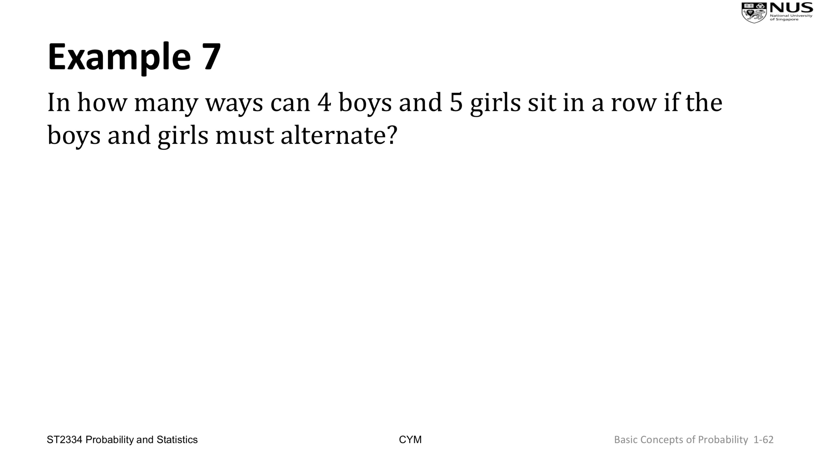
If 5 boys and 5 girls are to sit in a row, such that boys and girls are sitting alternatively, how many ways can we make the arrangement?
There are two sitting plans:
Plan 1: BGBGBGBGBG
Plan 2: GBGBGBGBGB
Therefore, the total number of ways is the number of ways for Plan 1 plus the number of ways for Plan 2.
For Plan 1, the number of ways is $5×5×4×4×3×3×2×2×1×1=5!×5!$; and likewise, for Plan 2, the number of ways is $5!×5!$ as well. So the total number of ways is $2×5!×5!=$28800.

Page 62 of Chapter1 Part 1
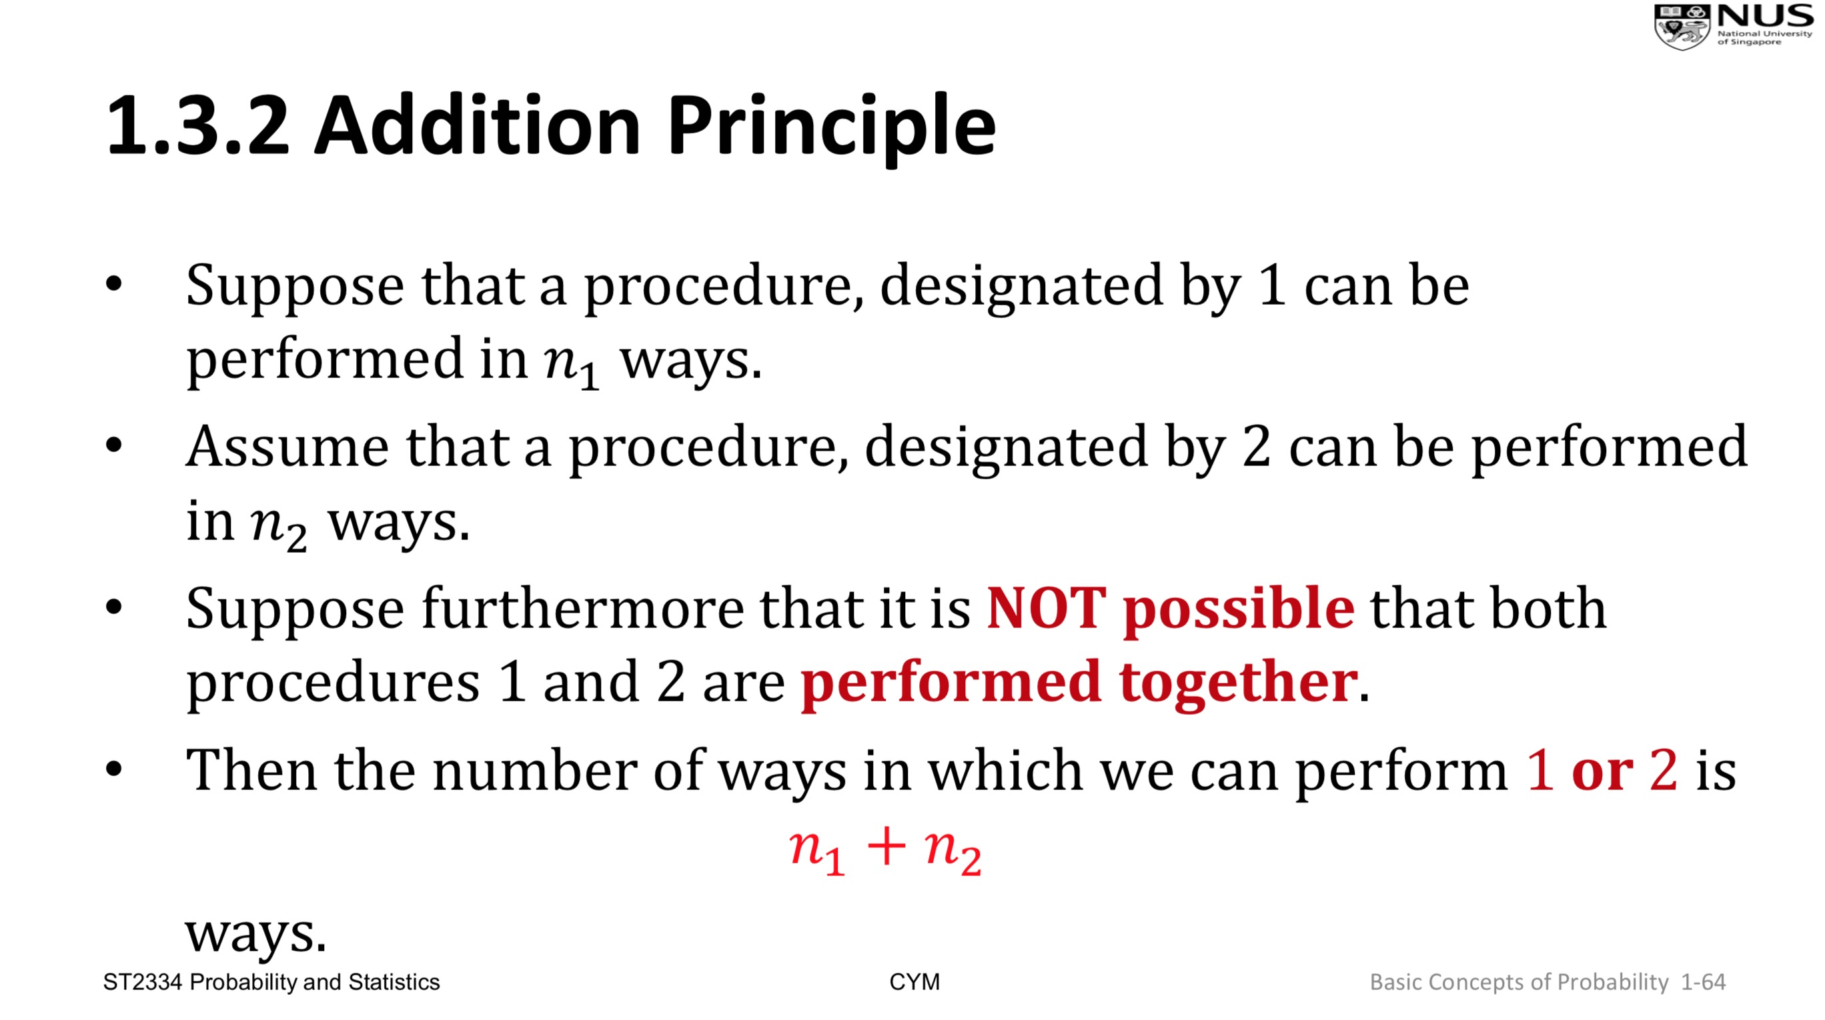
If we are doing parallel counting, “addition principle” takes effect; if we are doing sequential counting, “multiplication rule” applies. The example in the last page in fact has jointly used both principles. In particular, “Plan 1” and “Plan 2” parallel, so “addition principle” should be used; therefore, we add the number ways based on “Plan 1” and those based on “Plan 2”. Then, when computing the number of ways for each Plan, Plan 1 say, “multiplication principle” has been applied, we assume that kids are sitting from left to right sequentially.

Page 107 of Chapter1 Part 1
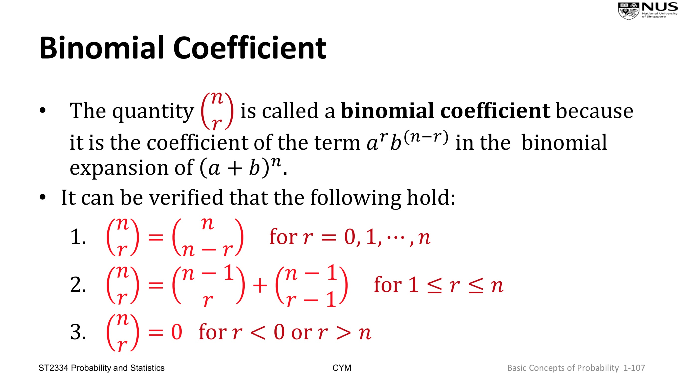
The first statement in this page means:
${(a+b)}^{n}=\left(\frac{n}{n}\right)a^{n}+\left(\frac{n}{n-1}\right)a^{n-1}b+\left(\frac{n}{n-2}\right)a^{n-2}b^{2}+…+\left(\frac{n}{1}\right)ab^{n-1}+\left(\frac{n}{0}\right)b^{n}$. (1)
A direct consequence of this formula is, by setting $a=b=1$,
$$2^{n}= \left(\frac{n}{n}\right)+\left(\frac{n}{n-1}\right)+\left(\frac{n}{n-2}\right)+…+\left(\frac{n}{1}\right)+\left(\frac{n}{0}\right).$$
Note: This last formula is able to be used to verify the statement we claimed in the 3rd page of this document: “for a sample space with n number of possible sample points, there are $2^{n}$ number of possible events”.
An approach to achieve the expansion in (1) is as follows:
- Let’s think ${(a+b)}^{n}=\left(a+b\right)\left(a+b\right)⋯\left(a+b\right)= Factor1×Factor2×⋯×Factorn$ , i.e., the multiplication of n number of “$(a+b)$”s. When expanding this formula directly with algebra, we shall get $2^{n}$ expanded terms: $\left(a+b\right)\left(a+b\right)⋯\left(a+b\right)=E1+E2+…+E2^{n}$. Here $Ei$ is a product of $n$ factors, i.e., $Ei=T1×T2×⋯×Tn$ with $T1(=a or b)$ from $Factor1$, $T2(=a or b)$ from $Factor2$, and so on.
- Now, we can count that among all these $Ei's$:
  - the number of $Ei$’s that are equal to $a^{n}$ should be $\left(\frac{n}{n}\right)$: all the corresponding $T1, T2, ⋯,Tn$ must be $a$. So the coefficient for $a^{n}$ is $\left(\frac{n}{n}\right)$.
  - the number of $Ei$’s that are equal to $a^{n-1}b$ should be $\left(\frac{n}{n-1}\right)$: out of all the $T1, T2, ⋯,Tn$, $n-1$ of them must be $a$, and the rest must be $b$. So the coefficient for $a^{n-1}b$ is $\left(\frac{n}{n-1}\right)$.
  - the number of $Ei$’s that are equal to $a^{n-2}b^{2}$ should be $\left(\frac{n}{n-2}\right)$: out of all the $T1, T2, ⋯,Tn$, $n-2$ of them must be $a$, and the rest must be $b$. So the coefficient for $a^{n-2}b^{2}$ is $\left(\frac{n}{n-2}\right)$.
  - …..
  - the number of $Ei$’s that are equal to $b^{n}$ should be $\left(\frac{n}{0}\right)$: out of all the $T1, T2, ⋯,Tn,$0 of them must be $a$, and the rest must be $b$. So the coefficient for $b^{n}$ is $\left(\frac{n}{0}\right)$.

